

**A**

**PROJECT DESIGN REPORT**

**ON**

**“<<WEB APPLICATION TO CONVERT YOUTUBE CAPTIONS INTO SIGN LANGUAGE>>”**

For the subject **Lab1 Project Phase 1**

Submitted in partial fulfillment of the requirement for the award of

**Bachelor of Engineering**

**In**

**Computer Science and Engineering**

**Solapur University, Solapur**

By

|  |  |  |
| --- | --- | --- |
| Name | Roll. No. | Exam Seat No. |
| Drushti Luhadiya | 13 | 738715 |
| Purvashi Dhakad | 14 | 738602 |
| Shaurya Jain | 15 | 738606 |
| Manjula Hiremath | 16 | 738588 |

Under Guidance Of

**Mr. P.S.R. PATNAIK**



**DEPARTMENT OF COMPUTER SCIENCE AND ENGINEERING**

**WALCHAND INSTITUE OF TECHNOLOGY**

**SOLAPUR - 413006**

**(2018-2019)**



**CERTIFICATE**

This is to certify that the Project entitled

**“WEB APPLICATION TO CONVERT YOUTUBE CAPTIONS INTO SIGN LANGUAGE”**

Is

Submitted by

|  |  |  |
| --- | --- | --- |
| Name | Roll. No. | Exam Seat No. |
| Drushti Luhadiya | 13 | 738715 |
| Purvashi Dhakad | 14 | 738602 |
| Shaurya Jain | 15 | 738606 |
| Manjula Hiremath | 16 | 738588 |

As a part of Project Design Report.

Studying in BE CSE for the subject **Lab1 Project Phase 1**

**(Mr. P.S.R. PATNAIK) (Dr.R.V.Argiddi)**

***Project Guide Head***

**Dept of Computer Science & Engg**

**(Dr. S.A. Halkude)**

**Principal**

**DEPARTMENT OF COMPUTER SCIENCE AND ENGINEERING**

**WALCHAND INSTITUE OF TECHNOLOGY**

**SOLAPUR (2018-2019)**

**INDEX**

|  |  |  |
| --- | --- | --- |
| **Sr. No.** | **Topic** | **Page No.** |
| 1 | Abstract | 1 |
| 2 | Introduction | 2 |
| 3 | Background | 3 |
| 4 | Technologies Required | 4 |
| 5 | Objectives | 6 |
| 6 | Proposed Work | 7 |
| 7 | Work Planned for Next Semester | 9 |
| 8 | Summary | 10 |
| 9 | References | 11 |

1. **Abstract**

YouTube is a platform where many entertainment and informative videos are present, but unfortunately deaf and dumb people are unable to utilize them. For such people the system converts the YouTube captions into sign language. It provides a platform for the deaf and dumb people and act as a medium for them to understand the videos with the help of fingerspelling and an animated character. The fingerspelling is mainly used to describe the name of a person or place, though it plays along with the animated character.

The sign language is used for deaf and dumb people. The caption tracks are taken from the YouTube with the help of YouTube APIs [1]. The extraction of captions are done using the two API calls ‘caption.list [2] and caption.download [3]’. If the caption track of the video is not present then an error will be displayed.

1. **Introduction**

This web application is made with the purpose of converting the YouTube captions of a desired video into the sign language. This system is made for the deaf and dumb people who are unable to understand English. This application helps those people by converting the English caption to sign language. The sign language is displayed to user in the form of fingerspelling [4] or an animated character and displayed on the screen enacting the video with the help of caption tracks.

The idea here is to get the caption track from YouTube for the given video URL using the YouTube APIs [1]. The API calls used are‘caption.lsit’ [2] and ‘caption.download’ [3] .If the caption track is present in English language, then the web application gives output to user screen in the form of sign language.

The data of fingerspelling is images [4] of alphabets ‘a-z’ and numeric values ‘0-9’, while the animated character uses the ‘SiGML player [5]’ and ‘sigml files’ [6] to display the output on the screen.

1. **Background**

Earlier people used to shoot and record the videos of an actor performing the fingerspelling actions which can sometimes be inefficient. So, to overcome this ‘Hamburg notation system’ and ‘SiGML file player [6] is used’. There are many websites [7][8][9] and applications which can convert the simple English text to any selected sign language. Below is the list of few applications that converts text to sign language.

Apps

* ASL Translator [10]
* Pro Deaf Translator [11]
* Mimix3d sign language [12]

1. **Technologies Required**

**Front End:**

●    HTML:

                                 HTML stands for Hyper Text Mark-up Language.[13]

                                 It describes the structure of Web pages using mark-up.

                                 HTML elements are the building blocks of HTML pages.

●    JavaScript & jQuery:

                                       JavaScript is the programming language of HTML and the Web.

                                       We used it to make form elements functional.[14]

                                     jQuery is a cross platform JavaScript library designed to simplify the

                                      client-side scripting of HTML. We used it to make buttons do a

                                   particular task on a click.

●    Bootstrap & CSS:

                                        Bootstrap is a free and open source front end library for designing

                                        websites and web applications. It contains HTML and CSS base design

                                   templates for typography, fonts, buttons navigation and other interface

components, as well as optional JavaScript extensions. [15]

Unlike many web frameworks, it concerns itself with front end development only. We used it to style the form elements and make it more suitable for all the screen sizes.

**Back End:**

* PHP:

                   Hypertext pre-processor is a server-side scripting language design for

                         web development but also used as a general-purpose programming

 language [16]. All back end is written in it like connecting database

 inserting the data.

**Data Base:**

* MySQL:

MySQL is used to develop a database. [17] All data is stored in it,

                                using MySQL queries. These queries are written in php to select,

                                insert, update and delete the data in database.

**YouTube APIs:**

* Caption.list:

Returns a list of caption tracks that are associated with a specified video [2].

* Caption.download:

Returns the caption track in the desired format by using caption_id [3].

**Data:**

* For finger spelling [4]:

Hand images of alphabets ‘a-z’

Hand Images of numeric values ‘0-9’

* For animated character:

1. Hamburg Notation System [5]:

The Hamburg Sign Language Notation System, or HamNoSys is a direct correspondence between symbols and sound transcription system for all sign languages not only ASL, comparable to the IPA for oral languages. It was developed in 1985 at the [University of Hamburg](https://en.wikipedia.org/wiki/University_of_Hamburg), Germany.

1. SiGML file player [6]:

It supports the ‘.sigml files’ and play them. The sigml files are the XML files that has the data from ‘Hamburg notation system [5]’.

1. **Objectives**

The core objective of this application is the conversion of text language (YouTube captions) into Sign language. The system is user friendly and platform independent and thus it can be easily accessible by anybody and anywhere.

1. **Proposed Work**

This system takes the captions from YouTube and convert them in sign language . The system initially takes the input from user which is a URL to the YouTube video. The system takes the YouTube ‘video_id’ from the given URL and uses it to call the YouTube APIs. Here system makes two API calls, first ‘caption.list [2]’ and second ‘caption.downlaod [3]’. The first ‘caption.list [2]’ takes ‘video_id’ as the parameter and gives the information about all the caption tracks available for the video along with their ‘caption_id’. If the caption track is present in English language it takes the ‘caption_id’ and passes it to ‘caption.download [3]’ API call .If the caption track is not present or is not available in English language then an error message is displayed on the user’s screen. If caption is downloaded successfully the system uses the ‘Hamburg notation system’ for the word used in the captions of the video and the ‘SiGML file player [6]’ displays the output as an animated character. Along with it there is a finger spelling caption tracks running. Both the outputs are in sync with the video because the timestamp present above every line of the caption track is used to play the signs in synchronization with the video.

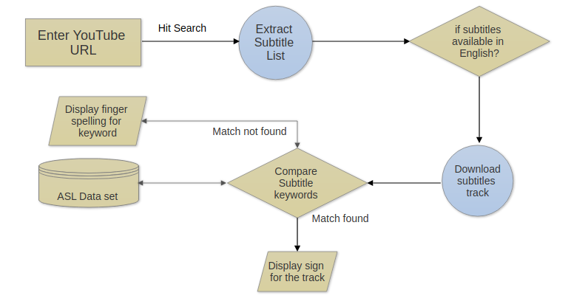

Fig: Architecture diagram and its working

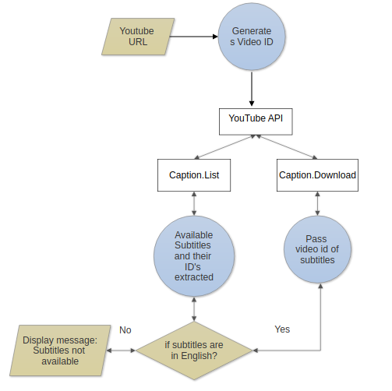

Fig: Working of YouTube APIs

1. **Work Planned for Next Semester**

Till now we are done with the outlining of the project, we have finalized the technology requirements, how we are going to use them, who will work on which part and we have evenly distributed the work among ourselves.

Firstly, we will find the algorithms which we will need for the conversion of YouTube captions to sign language. Then, we will work on the front end of the web application using HTML5, CSS, Bootstrap, JavaScript and jQuery. After that we need to work on back end using, Django and MySQL and at last we will work on the test cases, which will result in the best errorless project.

In the next semester each of us will work in our respective section of this project.

* Requirement analysis and data collection will be done by Purvashi Dhakad.
* Work related to Testing and test cases will be done by Drushti Luhadiya.
* Front end work will be done by Manjula Hiremath.
* Back end work will be done by Shaurya Jain.

1. **Summary**

This is a web application for the conversion of text language into sign language. Here the web application converts YouTube captions into sign language. The system combines all the necessities of a deaf person in one platform. The application is very easy to handle by the deaf people and they can easily access the YouTube videos by just copying the URL of YouTube videos in the search bar. This application assists them in understanding the YouTube videos in a simplified manner. With the help of our guide, tutorials and online help we will do our best for successful implementation of this idea.

1. **References**

[1] <https://en.wikipedia.org/wiki/YouTube_API>

[2] <https://developers.google.com/youtube/v3/docs/captions/list>

[3] <https://developers.google.com/youtube/v3/docs/captions/download>

[4] <https://www.signcommunity.org.uk/finger-spelling.html>

[5] <https://en.wikipedia.org/wiki/Hamburg_Notation_System>

[6] <http://vh.cmp.uea.ac.uk/index.php/Configuring_JASigning_for_HTML5_web_pages>

[7] <https://funtranslations.com/sign-language>

[8] <https://lingojam.com/SignLanguageTranslator>

[9] http://www.islfromtext.in/

[10] <https://itunes.apple.com/us/app/asl-translator/id421784745?mt=8>

[11] <https://play.google.com/store/apps/details?id=com.Proativa.ProDeafMovel&hl=en>

[12] <https://play.google.com/store/apps/details?id=com.mindrocketsinc.mimix&hl=en_US>

[13] https://en.wikipedia.org/wiki/HTML

[14] <https://opensourceforu.com/2016/07/basics-javascript-jquery/>

[15] https://en.wikipedia.org/wiki/Bootstrap_(front-end_framework)

[16] <http://php.net/manual/en/intro-whatis.php>

[17] <https://www.mysql.com/>